**Project Mission Statement:**

WholesaleApp - to create a space for Singaporeans to rate and share about hawker food. This project aims to create an accessible platform for Singaporeans to choose delicious, budget-friendly, and healthy food options all around Singapore.

**Functional Requirements:**

1. The website must have a login page.
   1. Users must be able to login using their account.
   2. Users must be able to continue as a guest.
2. The website must have a homepage to display an overview of the features of the website.
   1. The homepage must be able to show hawker centres nearby based on the users’ location.
   2. The homepage must show recommended food nearby based on the users’ location.
   3. The homepage must show recent feeds posted by the users.
3. The website must have a search bar.
   1. Users must be able to search related keywords
      1. Users must be able to filter the results by hawker centres
         1. Users must be able to filter the hawker centres by distance
         2. Users must be able to filter the hawker centres by rating
      2. Users must be able to filter the results by food
         1. Users must be able to filter the food by price
         2. Users must be able to filter the food by rating
   2. The search bar must subtly guide users to the specific term they are looking for through type-as-you-go functionality.
      1. The functionality must suggest the top ranked search suggestion based on partial string the users have typed.
4. The website must have a map
   1. Google map API must be used
      1. Google map is being used to display the hawker centres distributed around Singapore.
         1. Users must be able to click on the hawker centres displayed on the map to see more details.
         2. Users must be able to rate the hawker centre under the displayed hawker centres’ profile.
         3. Users must be able to leave their comment about hawker centre.
   2. Users must be able to get navigation to selected hawker centres
      1. The website must display optimal route for vehicle.
      2. The website must display optimal route for public transport.
      3. The website must display optimal route on foot.
5. Users must be able to create post to share food or food stalls.
   1. Users can post photos for feed
   2. Users can post videos for feed
   3. Users must add location to their post

**Non-Functional Requirements:**

1. Usability
   1. The website should have colour schemes that are easy to see
      1. Light mode, where the page is primarily brighter colours
      2. Dark mode, where the page is primarily darker colours
2. Security
   1. The password should be of length of 8 with at least one letter, number and special character.
   2. Personal data of users should not be disclosed without permission.
   3. The website should automatically log the users out if there is a change in the linked Google account.
3. Performance
   1. The location accuracy should be within 50 metres.
   2. The search result should load within 10 seconds
4. Reliability
   1. The website should have an uptime of more than 98%

**Initial Use Case Diagram**

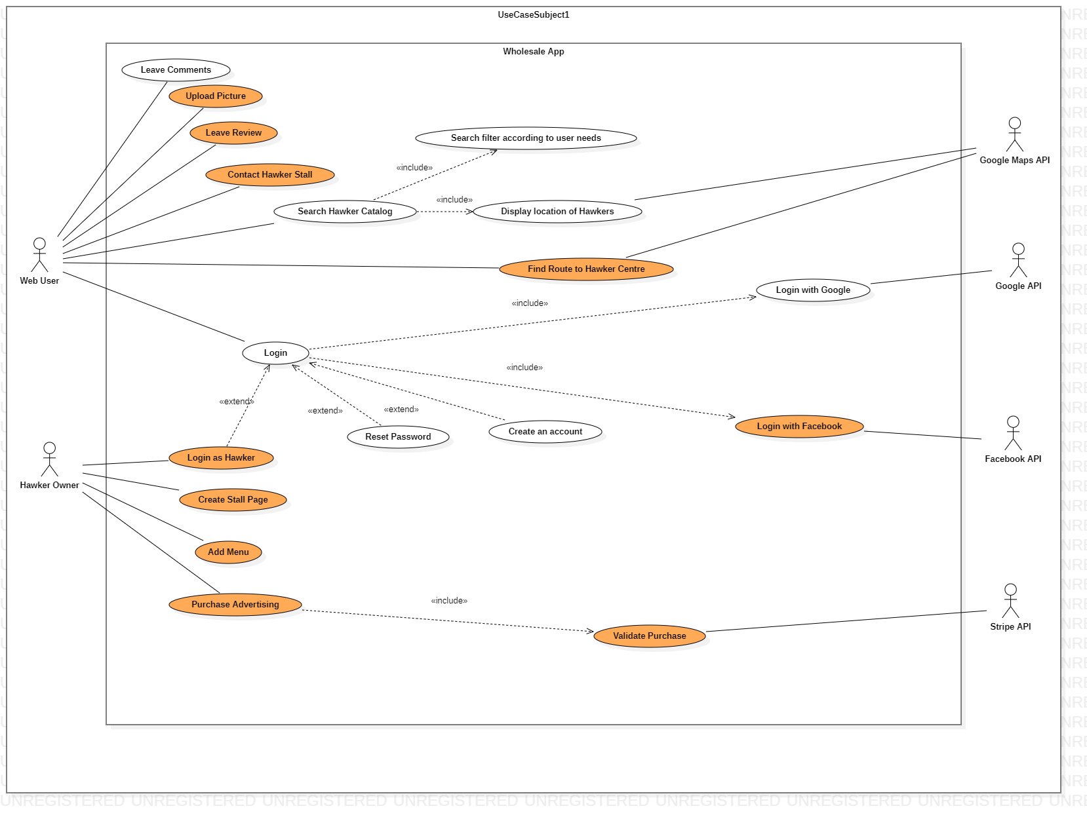

**Use Case Descriptions**

|  |  |  |  |  |
| --- | --- | --- | --- | --- |
| Use Case ID: |  | TEMPLATE | | |
| Use Case Name: |  | [FILL IN] | | |
| Created By: |  |  | Last Updated By: |  |
| Date Created: |  |  | Date Last Updated: |  |

|  |  |  |
| --- | --- | --- |
| Actor: |  | [REQUIRED] |
| Description: |  | [REQUIRED] |
| Preconditions: |  | [REQUIRED] |
| Postconditions: |  | [REQUIRED] |
| Priority: |  |  |
| Frequency of Use: |  |  |
| Flow of Events: |  | [REQUIRED] |
| Alternative Flows: |  | [REQUIRED] |
| Exceptions: |  |  |
| Includes: |  |  |
| Special Requirements: |  |  |
| Assumptions: |  |  |
| Notes and Issues: |  |  |

|  |  |  |  |  |
| --- | --- | --- | --- | --- |
| Use Case ID: |  | 1 | | |
| Use Case Name: |  | Search Hawker Catalog | | |
| Created By: |  | Zaki | Last Updated By: | Zaki |
| Date Created: |  | 26 Aug 2022 | Date Last Updated: | 29 Aug 2022 |

|  |  |  |
| --- | --- | --- |
| Actor: |  | Web User |
| Description: |  | User searches the database of hawker foods |
| Preconditions: |  | 1. User must be connected to WiFi/Mobile Data 2. User must be on the “Homepage” or “Search page” |
| Postconditions: |  | 1. User can view results pertaining to their search 2. User can gather information on related hawker stalls    1. Location    2. Price    3. Pictures 3. User can save the hawker stall to their favourites list |
| Priority: |  | Medium |
| Frequency of Use: |  | High |
| Flow of Events: |  | 1. User opens webpage 2. User clicks on search bar and makes a query 3. System checks user query against database 4. User is presented with hawker foods related to their query |
| Alternative Flows: |  | **AF-S1: User searches via search page**   1. User goes to search page 2. Return to step 2 |
| Exceptions: |  | - |
| Includes: |  | **Search Filter**   1. User may filter search results by various metrics    1. Location    2. Price    3. Calorie Count    4. Cuisine Type   **Display Hawker Location**   1. Using Google Maps API to present map of nearby hawkers 2. Display optimal route to nearby hawkers    1. On foot    2. By public transport    3. By vehicle |
| Special Requirements: |  | - |
| Assumptions |  | 1. Database has hawker stalls to query from    1. Submitted by other users |
| Notes and Issues |  | - |

|  |  |  |  |  |
| --- | --- | --- | --- | --- |
| Use Case ID: |  | 2 | | |
| Use Case Name: |  | Create a unique account | | |
| Created By: |  | Zaki | Last Updated By: | Zaki |
| Date Created: |  | 26 Aug 2022 | Date Last Updated: | 30 Aug 2022 |

|  |  |  |
| --- | --- | --- |
| Actor: |  | Web User |
| Description: |  | User creates an account on the web app to personalise their preferences and save hawker locations. Their account is transferable across devices and can be accessed remotely |
| Preconditions: |  | 1. User must be connected to WiFi/Mobile Data 2. User must be on the “Homepage” |
| Postconditions: |  | 1. User will have a unique account defined by a unique account username and password |
| Priority: |  | High |
| Frequency of Use: |  | Medium |
| Flow of Events: |  | 1. User opens webpage 2. User clicks “Create an account” 3. User enters their personal email 4. User enters a unique username 5. User enters a password 6. Confirmation email is sent 7. Username and password are logged into the database 8. User logs in using their unique username and password |
| Alternative Flows: |  | **AF-S4: Unique username already exists in the database**   1. User enters a different username 2. Return to step 5   **AF-S5: Password is not strong enough**   1. User is prompted for a different password 2. Password should contain at least 8 characters with a mixture of letters and numbers and inclusion of at least one special character 3. Return to step 6 |
| Exceptions: |  | - |
| Includes: |  | **Login with Google Account**   1. User logs in with pre-existing Google Account 2. Using Google API to validate user account 3. Refer to Use Case ID 6 |
| Special Requirements: |  | - |
| Assumptions |  | 1. User has a personal email |
| Notes and Issues |  | - |

|  |  |  |  |  |
| --- | --- | --- | --- | --- |
| Use Case ID: |  | 3 | | |
| Use Case Name: |  | Rate Hawker Centres | | |
| Created By: |  | Zaki | Last Updated By: | Zaki |
| Date Created: |  | 26 Aug 2022 | Date Last Updated: | 26 Aug 2022 |

|  |  |  |
| --- | --- | --- |
| Actor: |  | Web User |
| Description: |  | User rates the food from the hawker centres out of 5 stars after they have eaten the food. The user can upload photos of their food to share with other users. |
| Preconditions: |  | 1. User must be connected to WiFi/Mobile Data 2. User must have an account 3. User must be logged in to their account |
| Postconditions: |  | 1. User adds a food review to the database 2. Other users can access and view the review |
| Priority: |  | Low |
| Frequency of Use: |  | High |
| Flow of Events: |  | 1. User logs into their account 2. User clicks on “Review” button 3. User selects the location that they purchased food from 4. User selects a rating from 1 to 5    1. 1 representing a bad rating    2. 5 representing a good rating 5. User shares their review 6. Review is saved in the database |
| Alternative Flows: |  | **AF-S4: User shares a photo with their review**   1. User is prompted with a upload request 2. User can upload photos of their food 3. Return to step 5 |
| Exceptions: |  | - |
| Includes: |  | - |
| Special Requirements: |  | - |
| Assumptions: |  | 1. User has a file manager 2. User device has photos    1. Or device is capable of taking photos |
| Notes and Issues: |  | - |

|  |  |  |  |  |
| --- | --- | --- | --- | --- |
| Use Case ID: |  | 4 | | |
| Use Case Name: |  | Leave comments about hawker centres | | |
| Created By: |  | Zaki | Last Updated By: | Zaki |
| Date Created: |  | 26 Aug 2022 | Date Last Updated: | 30 Aug 2022 |

|  |  |  |
| --- | --- | --- |
| Actor: |  | Web User |
| Description: |  | Users can leave comments on other food reviews. |
| Preconditions: |  | 1. User must be connected to WiFi/Mobile Data 2. User must have an account 3. User must be logged in to their account |
| Postconditions: |  | 1. User leaves comments on other food reviews 2. Other users can view comments and leave comments of their own |
| Priority: |  | Medium |
| Frequency of Use: |  | High |
| Flow of Events: |  | 1. User logs into their account 2. User selects “Review” page 3. User is presented with reviews submitted by other users 4. User selects a review 5. User clicks on the “Comment” button 6. User writes a comment    1. Comments can contain text and emoticons 7. User submits the comment 8. Comment is saved in the database and tagged to the review |
| Alternative Flows: |  | **AF-S6: Comment contains offensive words**   1. Comments that contain offensive words are flagged 2. User will be prompted to change the phrasing of their comment 3. Return to step 7 |
| Exceptions: |  | - |
| Includes: |  | - |
| Special Requirements: |  | - |
| Assumptions: |  | 1. Database has reviews to query from    1. Submitted by other users |
| Notes and Issues: |  | - |

|  |  |  |  |  |
| --- | --- | --- | --- | --- |
| Use Case ID: |  | 5 | | |
| Use Case Name: |  | Log into account using email and password | | |
| Created By: |  | Zaki | Last Updated By: | Tan Yu |
| Date Created: |  | 26 Aug 2022 | Date Last Updated: | 05 Sep 2022 |

|  |  |  |
| --- | --- | --- |
| Actor: |  | Web User |
| Description: |  | User logs into their account using a unique username and password. |
| Preconditions: |  | 1. User must be connected to WiFi/Mobile Data 2. User must have an account 3. User must be on the “Homepage” |
| Postconditions: |  | 1. User is able to log into their account and retrieve their information and preferences 2. User is able to post reviews and comments |
| Priority: |  | High |
| Frequency of Use: |  | Medium |
| Flow of Events: |  | 1. User clicks on the “Login” button 2. User is presented with fields to enter their username and password 3. User enters their username 4. User enters their corresponding password 5. Information is validated against database 6. User logs in successfully |
| Alternative Flows: |  | **AF-S3: Username does not exist**   1. User is presented with an error message 2. User is prompted to enter their username again 3. Return to step 3   **AF-S4: Password is incorrect**   1. User is presented with an error message 2. User is prompted to enter their password again 3. Return to step 4   **AF-S4: Forgot password**   1. User is presented with an error message 2. User clicks on “Forgot password” 3. Refer to Use Case ID 8 |
| Exceptions: |  | - |
| Includes: |  | **Login with Google Account**   1. User logs in with pre-existing Google Account 2. Using Google API to validate user account 3. Refer to Use Case ID 6   **Login with Facebook Account**   1. Hawker logs in with pre-existing Facebook Account 2. Using Facebook API to validate hawker account 3. Refer to Use Case ID 16 |
| Special Requirements: |  | - |
| Assumptions: |  | - |
| Notes and Issues: |  | - |

|  |  |  |  |  |
| --- | --- | --- | --- | --- |
| Use Case ID: |  | 6 | | |
| Use Case Name: |  | Log into account using Google Account | | |
| Created By: |  | Zaki | Last Updated By: | Zaki |
| Date Created: |  | 26 Aug 2022 | Date Last Updated: | 30 Aug 2022 |

|  |  |  |
| --- | --- | --- |
| Actor: |  | Web User, Google API |
| Description: |  | User logs into web page using their Google Account. |
| Preconditions: |  | 1. User must be connected to WiFi/Mobile Data 2. User must have a Google Account 3. User must be on the “Homepage” |
| Postconditions: |  | 1. User is able to log into their account and retrieve their information and preference 2. User is able to post reviews and comments |
| Priority: |  | High |
| Frequency of Use: |  | Medium |
| Flow of Events: |  | 1. User clicks on the “Login” button 2. User is presented with fields to enter their username and password 3. User selects “Login with Google” 4. System validates account by checking against Google Database via Google API 5. User must grant permission to access their Google Account information 6. System will use Google Account details to save information and preferences 7. User logs in successfully |
| Alternative Flows: |  | **AF-S4: User enters their Google Account incorrectly**   1. Google API will prompt the user to enter their credentials again 2. User enters their credentials again 3. Return to step 4 |
| Exceptions: |  | - |
| Includes: |  | **Validate Account**   1. Google Account credentials will be validated using Google API |
| Special Requirements: |  | - |
| Assumptions: |  | - |
| Notes and Issues: |  | - |

|  |  |  |  |  |
| --- | --- | --- | --- | --- |
| Use Case ID: |  | 7 | | |
| Use Case Name: |  | Show top rated hawker centres nearby | | |
| Created By: |  | Zaki | Last Updated By: | Zaki |
| Date Created: |  | 26 Aug 2022 | Date Last Updated: | 30 Aug 2022 |

|  |  |  |
| --- | --- | --- |
| Actor: |  | Web User |
| Description: |  | User is shown recommendations of hawker centres based on location and ratings. |
| Preconditions: |  | 1. User must be connected to WiFi/Mobile Data 2. User must have location on their device enabled 3. User must be on the “Homepage” |
| Postconditions: |  | 1. User can view a list of top rated hawkers 2. User can save results to their favourites |
| Priority: |  | Medium |
| Frequency of Use: |  | High |
| Flow of Events: |  | 1. User clicks on the “Top Rated” page 2. System queries the database, returning listings based on location and rating 3. User is presented with hawker stalls rated 4 stars and above, within 1km of their location |
| Alternative Flows: |  | **AF-S1: Database doesn’t contain any entries**   1. User is presented with message stating that there are no results |
| Exceptions: |  | - |
| Includes: |  | - |
| Special Requirements: |  | - |
| Assumptions: |  | - |
| Notes and Issues: |  | - |

|  |  |  |  |  |
| --- | --- | --- | --- | --- |
| Use Case ID: |  | 8 | | |
| Use Case Name: |  | Upload Photo | | |
| Created By: |  | Tan Yu | Last Updated By: | Tan Yu |
| Date Created: |  | 05 Sep 2022 | Date Last Updated: | 05 Sep 2022 |

|  |  |  |
| --- | --- | --- |
| Actor: |  | Web User |
| Description: |  | User can upload photos onto the website |
| Preconditions: |  | 1. User must be connected to WiFi/Mobile Data 2. User must be logged in 3. User must be on the *Post" page |
| Postconditions: |  | 1. User must be able to view their post on their profile page 2. Other users must be able to see their post 3. Other users must be able to like their post 4. Other users must be able to comment on their post 5. Other users must be able to share their post |
| Priority: |  | Medium |
| Frequency of Use: |  | High |
| Flow of Events: |  | 1. User clicks on “Post” at the top of the page on menu bar 2. User uploads a picture along with caption and optional location tag 3. User finishes crafting post and submits it for uploading |
| Alternative Flows: |  | **AF-S1**   1. User is presented with a message stating that file selected is not one of the supported formats   **AF-S2**   1. User is presented with a message stating that image is inappropriate |
| Exceptions: |  | - |
| Includes: |  | - |
| Special Requirements: |  | Image must be of .jpg, .png, .jpeg, or .mp4 format |
| Assumptions: |  | - |
| Notes and Issues: |  | System will resize image and edit resolution such that image size does not exceed 20MB |

|  |  |  |  |  |
| --- | --- | --- | --- | --- |
| Use Case ID: |  | 9 | | |
| Use Case Name: |  | Leave Review | | |
| Created By: |  | Tan Yu | Last Updated By: | Tan Yu |
| Date Created: |  | 05 Sep 2022 | Date Last Updated: | 05 Sep 2022 |

|  |  |  |
| --- | --- | --- |
| Actor: |  | Web User |
| Description: |  | User can leave reviews of foods, stalls, and hawker centers. |
| Preconditions: |  | 1. User must be connected to WiFi/Mobile Data 2. User must be logged in 3. User must be on the *Post" page 4. User must enter textual descriptions of the food, stalls, and hawker centers |
| Postconditions: |  | 1. User must be able to view their post on their profile page 2. Other users must be able to see their post 3. Other users must be able to like their post 4. Other users must be able to comment on their post 5. Other users must be able to share their post |
| Priority: |  | Medium |
| Frequency of Use: |  | High |
| Flow of Events: |  | 1. User clicks on “Post” at the top of the page on menu bar 2. User enters a textual description of their experience 3. User has the option to rate the experience by taste, health, and value 4. User finishes crafting post and submits it for uploading |
| Alternative Flows: |  | **AF-S1**   1. User is presented with a message stating that the text contains banned or inappropriate words |
| Exceptions: |  | - |
| Includes: |  | - |
| Special Requirements: |  | Text post must not exceed 500 characters |
| Assumptions: |  | - |
| Notes and Issues: |  | - |

|  |  |  |  |  |
| --- | --- | --- | --- | --- |
| Use Case ID: |  | 10 | | |
| Use Case Name: |  | Create Stall Page | | |
| Created By: |  | Celine Tan | Last Updated By: | Celine Tan |
| Date Created: |  | 06 Sep 2022 | Date Last Updated: | 06 Sep 2022 |

|  |  |  |
| --- | --- | --- |
| Actor: |  | Hawker User |
| Description: |  | Hawker users can create their own stall page under respective hawker centres. |
| Preconditions: |  | 1. Hawker user must be connected to Wi-Fi/Mobile Data 2. Hawker user must be logged into hawker account 3. Hawker user must be on the create stall page 4. Hawker account must be verified |
| Postconditions: |  | 1. Hawker user must be able to add details on the stall page 2. Other users must be able to search the stall page 3. Others users must be able to see the stall page |
| Priority: |  | Medium |
| Frequency of Use: |  | Medium |
| Flow of Events: |  | 1. Hawker click ‘Create Stall’ button to submit stall registration request 2. Hawker user keys in the name of the stall 3. Hawker user adds the hawker centres where the stall belong to 4. Hawker user adds the location of the stall 5. System verifies the stall request. 6. Once the request is approved, every users can view the stall page |
| Alternative Flows: |  | **AF-S6: Request have not been approved**   1. System must tell the hawker users failed to create stall page and the reason of failed registration |
| Exceptions: |  | - |
| Includes: |  | - |
| Special Requirements: |  | The stall page name must match with the stall name on the provided food shop license |
| Assumptions: |  | - |
| Notes and Issues: |  | - |

|  |  |  |  |  |
| --- | --- | --- | --- | --- |
| Use Case ID: |  | 11 | | |
| Use Case Name: |  | Add Menu | | |
| Created By: |  | Celine Tan | Last Updated By: | Celine Tan |
| Date Created: |  | 06 Sep 2022 | Date Last Updated: | 06 Sep 2022 |

|  |  |  |
| --- | --- | --- |
| Actor: |  | Hawker User |
| Description: |  | Hawker users can add menu under their stall page |
| Preconditions: |  | 1. Hawker user must be connected to Wi-Fi/Mobile Data 2. Hawker user must be logged into a verified hawker account 3. Hawker user must own a stall page |
| Postconditions: |  | 1. Menu with details must be shown on respective stall page 2. Other users must be able to view the menu on the stall page |
| Priority: |  | Medium |
| Frequency of Use: |  | Medium |
| Flow of Events: |  | 1. Hawker user click into hawker profile 2. Hawker user click ‘Add Menu’ button to add menu under stall page 3. Hawker user add the name of the available dishes 4. Hawker user attach photos for each of the dishes 5. Hawker user include the price of each dishes 6. Hawker user can categorized the dishes into different categories |
| Alternative Flows: |  | **AF-S4 - Image size exceeds 600KB**   1. Hawker user is presented with a message stating that the image size is too large and ask the user to upload again |
| Exceptions: |  | - |
| Includes: |  | - |
| Special Requirements: |  | 1. The images uploaded must not exceed 600KB 2. Images must be of .jpg, .jpeg, or .png format |
| Assumptions: |  | - |
| Notes and Issues: |  | - |

|  |  |  |  |  |
| --- | --- | --- | --- | --- |
| Use Case ID: |  | 12 | | |
| Use Case Name: |  | Purchase Advertising | | |
| Created By: |  | Zaki | Last Updated By: | Zaki |
| Date Created: |  | 06 Sep 2022 | Date Last Updated: | 06 Sep 2022 |

|  |  |  |
| --- | --- | --- |
| Actor: |  | Hawker Owner |
| Description: |  | Hawker Owner can purchase advertising space, which boosts their stalls and product to the front page. Advertised stalls will be recommended to a larger number of web users. |
| Preconditions: |  | 1. Hawker user must be connected to Wi-Fi/Mobile Data 2. Hawker user must be logged into a verified hawker account 3. Hawker user must own a stall page |
| Postconditions: |  | 1. Hawker’s stall will be posted on the front page of the app 2. Web users will be recommended the advertised stall 3. Advertising lasts for preset length of time, based on the type of plan hawker owner has purchased |
| Priority: |  | Low |
| Frequency of Use: |  | Medium |
| Flow of Events: |  | 1. Hawker user selects “Purchase Advertising” 2. Hawker user selects the plan they intend to buy    1. 1 Day Plan    2. 1 Week Plan    3. 1 Month Plan    4. Subscription Plan 3. Hawker user verifies their payment information    1. Refer to Use Case ID 13 4. Payment is successful 5. Web users will be recommended the Hawker stall for the specified period of time |
| Alternative Flows: |  | **AF-S2: Hawker account have not been verified yet**   1. Hawker user is presented with a message stating that hawker account is not verified 2. Return to Step 2   **AF-S4: Payment is unsuccessful**   1. Stripe API returns an unsuccessful payment 2. Hawker user is presented with an error message and can attempt payment again |
| Exceptions: |  | - |
| Includes: |  | **Validate Purchase**   1. Purchase will be validated using Stripe API 2. Refer to Use Case ID 13 |
| Special Requirements: |  | - |
| Assumptions: |  | 1. Hawker user is able to make online payment 2. Hawker user owns a bank account- |
| Notes and Issues: |  | - |

|  |  |  |  |  |
| --- | --- | --- | --- | --- |
| Use Case ID: |  | 13 | | |
| Use Case Name: |  | Validate Purchase | | |
| Created By: |  | Zaki | Last Updated By: | Zaki |
| Date Created: |  | 06 Sep 2022 | Date Last Updated: | 06 Sep 2022 |

|  |  |  |
| --- | --- | --- |
| Actor: |  | Hawker Owner, Stripe API |
| Description: |  | Purchases made by Hawker Owner are validated using Stripe API. Stripe API will verify the payment methods and provide a successful or unsuccessful result. |
| Preconditions: |  | 1. Purchase has been made by Hawker Owner 2. Payment details has been entered by Hawker Owner |
| Postconditions: |  | 1. Payment is verified to be successful 2. Transaction by Hawker is copmleted |
| Priority: |  | Medium |
| Frequency of Use: |  | Medium |
| Flow of Events: |  | 1. Hawker user initiates a purchase 2. Hawker user inputs their payment details 3. Stripe API queries payment details 4. Stripe API verifies payment details with bank 5. Stripe API returns a successful payment |
| Alternative Flows: |  | **AF-S4: Payment details do not match with bank**   1. Stripe API returns an error message 2. Stripe API prompts user for another input |
| Exceptions: |  | - |
| Includes: |  | - |
| Special Requirements: |  | - |
| Assumptions: |  | 1. Stripe API server is running 2. Stripe API supports method of payment |
| Notes and Issues: |  | - |

|  |  |  |  |  |
| --- | --- | --- | --- | --- |
| Use Case ID: |  | 14 | | |
| Use Case Name: |  | Contact Hawker Stall | | |
| Created By: |  | Foo Jin Rui | Last Updated By: | Foo Jin Rui |
| Date Created: |  | 05 Sept 2022 | Date Last Updated: | 05 Sept 2022 |

|  |  |  |
| --- | --- | --- |
| Actor: |  | Web User |
| Description: |  | Web User contacts the hawker stall of their choice. |
| Preconditions: |  | 1. Web User must be connected to Wi-Fi/Mobile Data. 2. Hawker stall of the Web User’s choice must have a stall page on the application. 3. Hawker stall of the Web User’s choice must submit their contact information to the application. 4. Web User must be on the profile page of the hawker stall of their choice. |
| Postconditions: |  | 1. Web User is presented with the contact information of the hawker stall of their choice. Contact information can be the caller id or the email of the hawker owner or both. |
| Priority: |  | Low |
| Frequency of Use: |  | Low |
| Flow of Events: |  | 1. Web User clicks on “Contact Hawker”. 2. Contact information will be presented to the Web User. |
| Alternative Flows: |  | - |
| Exceptions: |  | - |
| Includes: |  | - |
| Special Requirements: |  | - |
| Assumptions: |  | - |
| Notes and Issues: |  | - |

|  |  |  |  |  |
| --- | --- | --- | --- | --- |
| Use Case ID: |  | 15 | | |
| Use Case Name: |  | Find Route to Hawker Centre | | |
| Created By: |  | Foo Jin Rui | Last Updated By: | Foo Jin Rui |
| Date Created: |  | 05 Sept 2022 | Date Last Updated: | 05 Sept 2022 |

|  |  |  |
| --- | --- | --- |
| Actor: |  | Web User |
| Description: |  | Web User can find a way from their current location to the hawker centre of their choice. |
| Preconditions: |  | 1. Web User must be connected to Wi-Fi/Mobile Data 2. Web User must have location on their device enabled. 3. Web User must be on profile page of the hawker centre of their choice. |
| Postconditions: |  | 1. Web User will be shown a live route from their location to the hawker centre of their choice that is optimised using Google Maps API. |
| Priority: |  | Medium |
| Frequency of Use: |  | Medium |
| Flow of Events: |  | 1. Web User clicks on “Find Me” 2. Web User is directed to a new page showing the live route from their location to the hawker centre. |
| Alternative Flows: |  | - |
| Exceptions: |  | - |
| Includes: |  | - |
| Special Requirements: |  | - |
| Assumptions: |  | - |
| Notes and Issues: |  | - |

|  |  |  |  |  |
| --- | --- | --- | --- | --- |
| Use Case ID: |  | 16 | | |
| Use Case Name: |  | Log into account using Facebook Account | | |
| Created By: |  | Tan Yu | Last Updated By: | Tan Yu |
| Date Created: |  | 05 Sep 2022 | Date Last Updated: | 05 Sep 2022 |

|  |  |  |
| --- | --- | --- |
| Actor: |  | Web User, Facebook API |
| Description: |  | User logs into web page using their Facebook Account. |
| Preconditions: |  | 1. User must be connected to WiFi/Mobile Data 2. User must have a Facebook Account 3. User must be on the “Homepage” |
| Postconditions: |  | 1. User is able to log into their account and retrieve their information and preference 2. User is able to post reviews and comments |
| Priority: |  | High |
| Frequency of Use: |  | Medium |
| Flow of Events: |  | 1. User clicks on the “Login” button 2. User is presented with fields to enter their username and password 3. User selects “Login with Facebook” 4. System validates account by checking against Facebook Database via Facebook API 5. User must grant permission to access their Facebook Account information 6. System will use Facebook Account details to save information and preferences 7. User logs in successfully |
| Alternative Flows: |  | **AF-S4: User enters their Facebook Account incorrectly**   1. Facebook API will prompt the user to enter their credentials again 2. User enters their credentials again 3. Return to step 4 |
| Exceptions: |  | - |
| Includes: |  | **Validate Account**   1. Facebook Account credentials will be validated using Facebook API |
| Special Requirements: |  | - |
| Assumptions: |  | - |
| Notes and Issues: |  | - |

|  |  |  |  |  |
| --- | --- | --- | --- | --- |
| Use Case ID: |  | 17 | | |
| Use Case Name: |  | Log into hawker account using email and password | | |
| Created By: |  | Tan Yu | Last Updated By: | Tan Yu |
| Date Created: |  | 05 Sep 2022 | Date Last Updated: | 05 Sep 2022 |

|  |  |  |
| --- | --- | --- |
| Actor: |  | Web User |
| Description: |  | Hawker logs into their account using a unique username and password. |
| Preconditions: |  | 1. User must be connected to WiFi/Mobile Data 2. User must have an account 3. User must be on the “Homepage” |
| Postconditions: |  | 1. Hawker is able to log into their account and retrieve their information and preferences 2. Hawker is able to post reviews and comments 3. Hawker can create hawker page |
| Priority: |  | High |
| Frequency of Use: |  | Medium |
| Flow of Events: |  | 1. Hawker clicks on the “Login” button 2. Hawker is presented with fields to enter their username and password 3. Hawker enters their username 4. Hawker enters their corresponding password 5. Information is validated against database 6. Hawker logs in successfully |
| Alternative Flows: |  | **AF-S3: Username does not exist**   1. Hawker is presented with an error message 2. Hawker is prompted to enter their username again 3. Return to step 3   **AF-S4: Password is incorrect**   1. Hawker is presented with an error message 2. Hawker is prompted to enter their password again 3. Return to step 4   **AF-S4: Forgot password**   1. Hawker is presented with an error message 2. Hawker clicks on “Forgot password” 3. Refer to Use Case ID 8 |
| Exceptions: |  | - |
| Includes: |  | **Login with Google Account**   1. Hawker logs in with pre-existing Google Account 2. Using Google API to validate hawker account 3. Refer to Use Case ID 6   **Login with Facebook Account**   1. Hawker logs in with pre-existing Facebook Account 2. Using Facebook API to validate hawker account 3. Refer to Use Case ID 16 |
| Special Requirements: |  | - |
| Assumptions: |  | - |
| Notes and Issues: |  | - |

**Class Diagram**

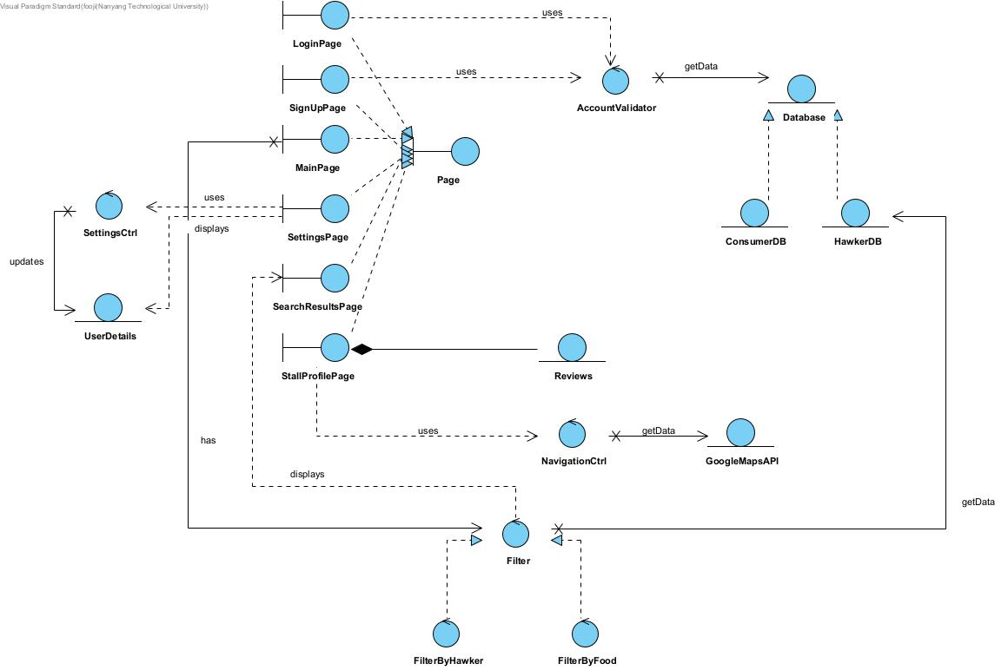

**Sequence Diagram**

Create a Unique Account

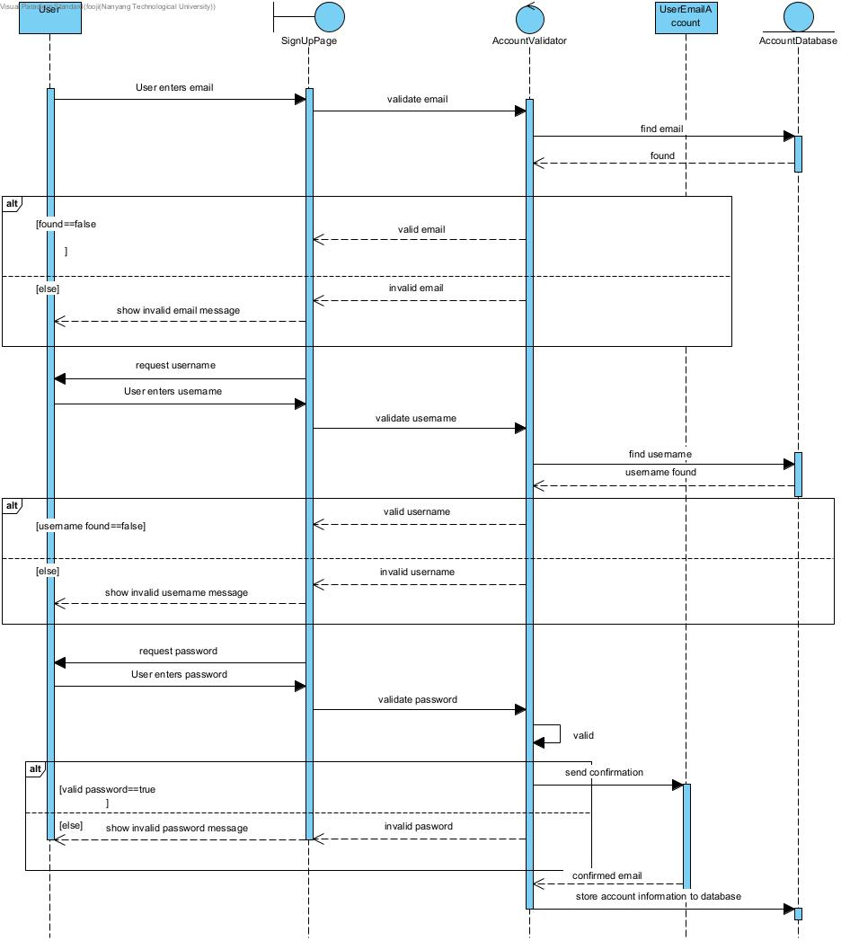

Create Stall Profile

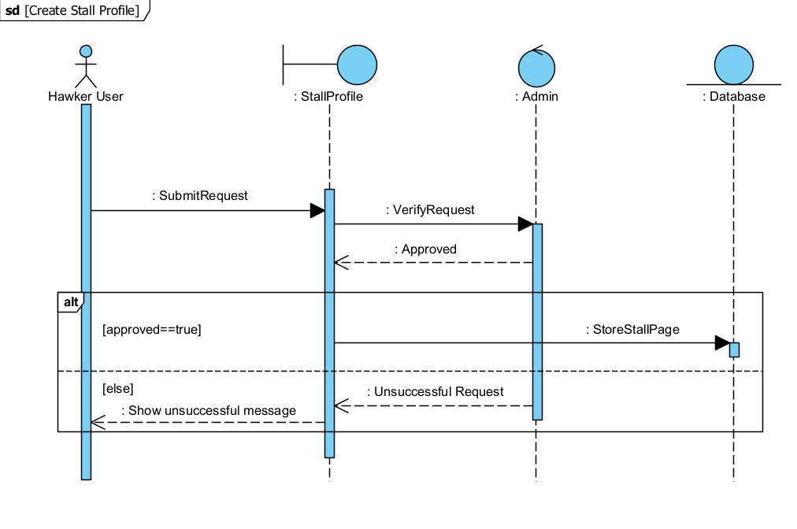

**Leave Review**

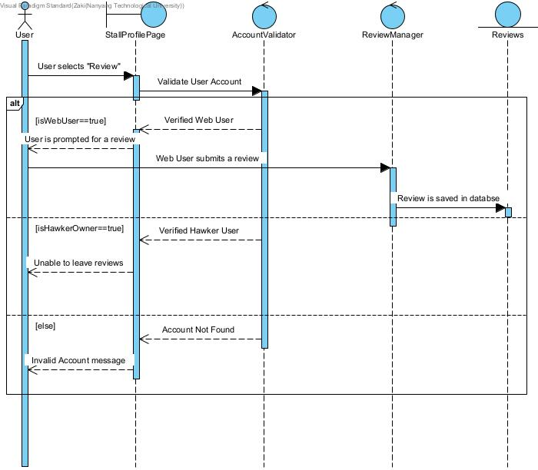

**Search Form**

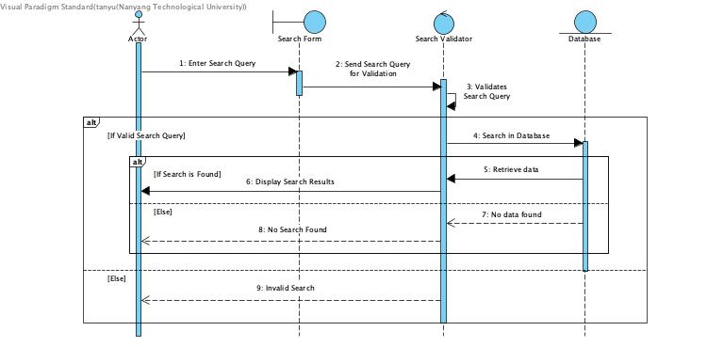

**Initial Dialog Map**

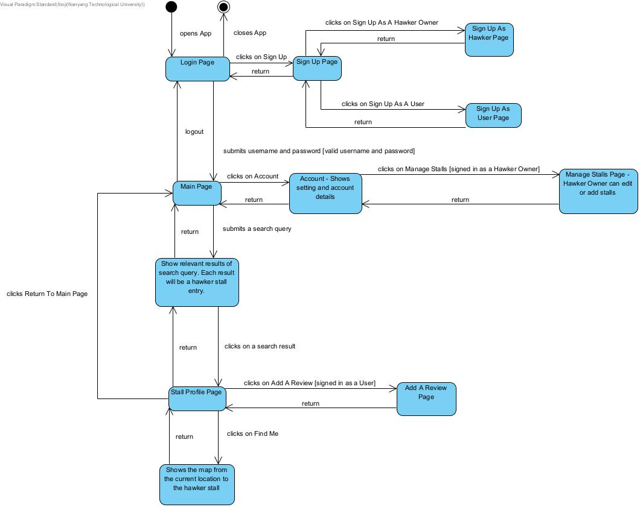

**Data Dictionary**

|  |  |  |  |  |  |
| --- | --- | --- | --- | --- | --- |
| Field Name | Data Type | Data Format | Field Size | Description | Example |
| Hawker Centre | Text | - | 100 | An open air market at which individual vendors sell ready-to-eat food from small booths | Maxwell Food Centre |
| Account | Text | - | - | A unique profile that stores a user’s personal information and saved information in the app | - |
| Unique Account Username | Text | - | 20 | A unique identifier used to gain access to a computer, network or online system | Lim Jun Jie |
| Account Password | Text | At least 8 characters with a mixture of letters and numbers and inclusion of at least one special character | 20 | A string of characters used to verify the identity of a user during the authentication process. | 8xiJ55KE#oz |
| Rating | Category | Integer value from 1 to 5 | 1 | Classification of a hawker food stall based on the user’s impression of their food | 3 |
| Comment | Text |  | 200 | Written remark expressing an opinion or reaction of a hawker food stall by the user | Fresh fish soup with rice, porridge, or bee hoon is available. The soup broth was delicious, and it was cooked to perfection |
| Distance | Integer | Kilometers | 2 | Physical distance between the user and the desired hawker  centre | 3.2 kilometers |
| Region | Category | North, North-East, South, East, West or Central | 20 | Urban planning subdivisions demarcated by the Urban Redevelopment Authority of Singapore | North-East |
| Type of Diet | Category | Non-Halal, Halal, Vegetarian or Vegan | 20 | The kinds of food that a person habitually eats | Vegan |